NAME: RAMYA RAMESH

USN: 1BM19CS227

**PROGRAM 10: HEAP SORT**

1. RANDOM GENERATED:

#include <stdio.h>

#include <stdlib.h>

#include <time.h>

void swap(int *a, int *b) {

int temp = *a;

*a = *b;

*b = temp;

}

void heapify(int arr[], int n, int i) {

int large = i;

int l = 2 * i + 1;

int r = 2 * i + 2;

if (l < n && arr[l] > arr[large])

large = l;

if (r < n && arr[r] > arr[large])

large = r;

if (large != i) {

swap(&arr[i], &arr[large]);

heapify(arr, n, large);

}

}

void HeapSort(int arr[], int n) {

for (int i = n / 2 - 1; i >= 0; i--)

heapify(arr, n, i);

for (int i = n - 1; i >= 0; i--) {

swap(&arr[0], &arr[i]);

heapify(arr, i, 0);

}

}

int main() {

clock_t start,end;

double time;

int arr[100000], n, i;

printf("Enter the size of the array:\n");

scanf("%d", &n);

printf("Enter the elements in the array:\n");

for (i = 0; i < n; i++)

{

arr[i] = rand()%100;

printf("%d ",arr[i]);

}

start = clock();

HeapSort(arr, n);

end = clock();

printf("\nSorted array is \n");

for (i = 0; i < n; i++)

{

printf("%d ", arr[i]);

}

printf("\n");

time = ((double)(end - start))/CLOCKS_PER_SEC;

printf("\nTime taken : %lf\n",time);

}

OUTPUT:

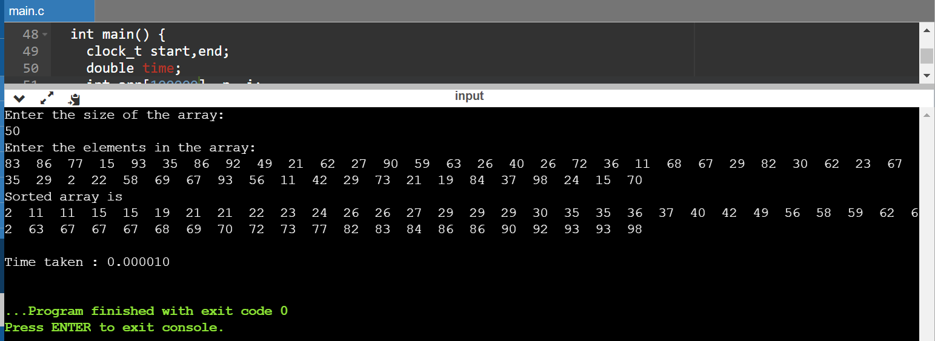

|  |  |
| --- | --- |
| N | Time |
| 50 | 0.000010 |
| 100 | 0.000019 |
| 200 | 0.000042 |
| 500 | 0.000127 |
| 1000 | 0.000228 |
| 5000 | 0.001334 |
| 10000 | 0.003058 |
| 15000 | 0.004706 |
| 20000 | 0.007041 |
| 25000 | 0.008934 |

1. MANUAL (USER INPUT):

#include <stdio.h>

#include <stdlib.h>

#include <time.h>

void swap(int *a, int *b) {

int temp = *a;

*a = *b;

*b = temp;

}

void heapify(int arr[], int n, int i) {

int large = i;

int l = 2 * i + 1;

int r = 2 * i + 2;

if (l < n && arr[l] > arr[large])

large = l;

if (r < n && arr[r] > arr[large])

large = r;

if (large != i) {

swap(&arr[i], &arr[large]);

heapify(arr, n, large);

}

}

void HeapSort(int arr[], int n) {

for (int i = n / 2 - 1; i >= 0; i--)

heapify(arr, n, i);

for (int i = n - 1; i >= 0; i--) {

swap(&arr[0], &arr[i]);

heapify(arr, i, 0);

}

}

int main() {

clock_t start,end;

double time;

int arr[100],n,i;

printf("Enter the size of the array:\n");

scanf("%d",&n);

printf("Enter the elements in the array:\n");

for (i = 0; i < n; i++)

{

scanf("%d",&arr[i]);

}

start = clock();

HeapSort(arr, n);

end = clock();

printf("\nSorted array is \n");

for (i = 0; i < n; i++)

{

printf("%d ", arr[i]);

}

printf("\n");

time = ((double)(end - start))/CLOCKS_PER_SEC;

printf("\nTime taken : %lf\n",time);

}

